**GUIDELINES FOR AUTHORS**

We are delighted and honoured by your interest in publishing your research in the ASHUES Journal. To ensure a seamless submission process and maintain the quality and standards of our journal, please carefully review the following guidelines:

**1. Focus and Scope of ASHUES Journal**

* ASHUES Journal prioritizes *updated, fresh, and contemporary economics topics*.
* Articles must adopt an *interdisciplinary research approach* and address *international or regional-level issues*. Single-country-focused studies are discouraged.

**2. Data and Analysis Requirements**

* Submissions must include **data and statistical analysis from European countries and/or the USA**, in alignment with the journal's mission to highlight cross-border economic processes.
* Comparative analyses between your country's data and those of European or American contexts are strongly encouraged to increase citation potential.

**3. References and Citations**

* Use references primarily from **SCOPUS, ISI, WoS, or CA-indexed journals** published within the last 1-3 years.
* Citing related articles previously published in ASHUES is highly recommended to support the journal’s research network.

**4. Paper Submission Guidelines**

* **Language**: Manuscripts must be written entirely in English, clearly and concisely, without ambiguities.
* **Length**: Articles must range between *6 to 20 pages*. Submissions not adhering to this requirement may be rejected.
* **Formatting**: Use the official ASHUES template to ensure proper formatting, spacing, alignment, and referencing. Non-compliant submissions will be returned to authors for revisions.
  + For articles persistently not meeting requirements but still requested for publication, a **processing fee of €200** will apply. These will be considered for future issues upon payment.

**5. Manuscript Structure**

* Include the **Title** within the manuscript to clearly identify the focus of your work.
* Provide **Complete Author Information**: Full names, affiliations, addresses, and individual email addresses for all authors (we do not accept a single email for all contributors).
* Add **Abstract, Keywords, and JEL Classification Codes**: A structured abstract, a relevant keyword list, and appropriate JEL codes are required for discoverability.
* Generalize your **Title** for broader appeal, avoiding specific names of countries, regions, or companies.

**6. Research Focus**

* Articles must emphasize *modern, interdisciplinary economic research* with comparative or regional studies.
* Studies focusing exclusively on a single country, region, or company are unlikely to be accepted unless they incorporate broader international perspectives.

**7. Peer Review and Publication Timeline**

* The **peer-review process** takes approximately *2-3 weeks to one month or more*.
* **Issue 1**, scheduled for release at the **end of March**, authors must meet the submission and revision deadlines until 20th of March.
* **Issue 2**, scheduled for release at the **end of June**, authors must meet the submission and revision deadlines until 20th of June.
* **Issue 3**, scheduled for release at the **end of September**, authors must meet the submission and revision deadlines until 20th of September.
* **Issue 4**, scheduled for release at the **end of December**, authors must meet the submission and revision deadlines until 10th of December.

**8. New Submissions and Returning Authors**

* **New Submissions:** If you are submitting to ASHUES for the first time and do not have an account, please contact us at [ashues@spiruharet.ro](mailto:ashues@spiruharet.ro) to request login credentials. These credentials will enable you to upload your paper on the journal platform.
* **Returning Authors:** If you have submitted to ASHUES before, please log in using your existing account credentials. If you have forgotten your password, you can reset it on the ASHUES website.

**9. Submission Timeline**

* Authors are required to submit revised articles within *1-3 days* of receiving feedback.
* Delays in returning the final version may result in publication being deferred to the next journal issue.

By adhering to these guidelines, you enhance the quality and impact of your research while contributing to the growing reputation and citation capacity of the ASHUES Journal. Thank you for your understanding and cooperation. We look forward to your valuable contributions!

**PAPER STRUCTURE AND FORMATTING DETAILS**

**Page Setup**: Text margins: bellow – 2.5 cm; right – 2.5 cm; top – 2.5 cm; left – 2.5 cm; page format A4. The text will be written in single line spacing, justified alignment.

**Format paragraph**: All paragraphs should be setting Alignment - Justify, left – 0 cm, right – 0 cm, before – 0 pt, after – 0 pt, Special – First line – 1,27 cm.

**TITLE OF THE PAPER PUBLISHED IN ANNALS OF SPIRU HARET UNIVERSITY. ECONOMIC SERIES**

**(centered, bold, Times New Roman, 14 pt., CAPS LOOK)**

(SINGLE SPACE, Times New Roman, 14pt.)

**Name SURNAME1 of the first author, Name SURNAME2 of the second author (centered, Times New Roman, bold, 12pt.)**

***Attention! Affiliation and contacts for all the authors it is required and compulsory.***

***Please fill in the authors names and affiliations on the online platform of the journal, too.***

***1Organisation, Address, City, Postcode, Country***

***Phone, Fax, Email address***

***2Organisation, Address, City, Postcode, Country***

***Phone, Fax, Email address***

**(centered, Times New Roman, bold and italic , 12pt.)**

(DOUBLE SPACE, Times New Roman, 14 pt.)

**How to cite:** Andreescu, M, Sinescu, S.# (2025**). “Risk Management and Judgement of Financial Managers in Decision-Making”***. Annals of Spiru Haret University. Economic Series, 25(4)****, 15-18$, doi: https://doi.org/10.26458/2441$

**Abstract (Times New Roman, bold, 12 pt.)**

*No more than 200 words and less that 150. The abstract must clearly specify the purpose of the paper and the objectives pursued by the author by his/her study. To be written in Times New Roman, 12 pt, italic.*

(Single space, Times New Roman, 12 pt.)

**Keywords (Times New Roman, bold, 12 pt.):** *five-six key words, defining the subject approached in the paper. To be written in Times New Roman, 12 pt., italic.*

**JEL Classification (Times New Roman, bold, 12 pt.):** shall be written in accordance with the*Journal of Economic Literature* (JEL). The authors shall visit **http://www.aeaweb.org/journal/jel_class_system.php** for rapid guidelines*. To be written in Times New Roman New Roman, italic,12 pt.*

(Double space, Times New Roman, 12 pt.)

**Introduction (Times New Roman, bold, 12 pt.)**

The introduction shall have a page at the most, however not less than half a page. The text must provide answers for four questions. (1) What matter does the paper cover? (2) Why is the studied matter important? (3) How does the author intend to answer to this matter? (4) What is the relation between the paper and the already existent specialized literature? This introductory section shall be written clearly and any confusion in communicating the four answers might result in paper rejection. (Times New Roman New Roman, 12 pt*.*)

(SINGLE SPACE, Times New Roman, 12)

**Literature Review (Times New Roman, bold, 12 pt.)**

This section must comprise referrals to specialized literature, compared against the paper’s subject, emphasizing the most important and relevant contributions on which the author will ground his/her argumentation. In the reviewing process there shall be taken into consideration the share of referrals to papers published in international journals recognized by the scientific community. This section must stress the fact that the author is familiar with the knowledge level in the studied area, that he/she has sufficient scientific training, allowing him/her to have a pertinent opinion over the studied issues. (Times New Roman, 12 pt.)

(SINGLE SPACE, Times New Roman, 12)

**Theoretical Background (Times New Roman, bold, 12 pt.)**

This section presents (if the case) the used theoretical tools: models, calculation formula. Also, any potential statistic data will be referred to, as well as their source and processing manner. (Times New Roman, 12 pt.)

(SINGLE SPACE, Times New Roman, 12 pt.)

**Paper content (headline depending on the specific of the approach subject) (Times New Roman, bold, 12 pt.)**

In this section (or set of sections, as the case might be) the author shall present and support the results he/she intents to communicate by means of the paper. The references to literature should be noted in the main text **in 12 point Times New Roman New Roman font**, in the following form: [Barr, 2012]; [Blake, 2006; Barr, 2008]; [Barr & Diamond, 2008]; [Casey *et al.*, 2003]; [IMF, 2014]. **Footnotes should be avoided**.(Times New Roman, 12 pt.)

(SINGLE SPACE, Times New Roman, 12 pt.)

**Conclusions (Times New Roman, bold, 12 pt.)**

The conclusions section shall cover three elements: (1) it shall summarize the main outcomes; (2) it shall undertake the implications of such outcomes; (3) suggestions for future researches. (Times New Roman, 12 pt.)

(DOUBLE SPACE, Times New Roman, 12 pt.)

**References (Times New Roman, bold, 12 pt.)**

References shall be written in accordance with the Chicago Manual of Style. The authors shall visit http://www.apastyle.org/manual for rapid guidelines. (Times New Roman,11 pt.). References are **mandatory**. There are not accepted footnotes, but only endnotes where the case.

Please, list the references in alphabetical order at the end of the paper in the reference section as in the examples taken from *APA Manual of Style*:

**Book**

1. A. Gray. *Modern Differential Geometry*. CRE Press, 1998.

**Journal article**

1. Weerasinghe, R., & Jayawardane, A. (2018). University-Industry Partnerships for Innovation: Sri Lankan Experiences. Annals of Spiru Haret University. Economic Series, 18(1), 25-45., doi:<https://doi.org/10.26458/1811>

**Case study**

1. Martinez-Polo, J., Martínez-Sánchez, J. (2018). Reputation and Trust in Sharing Economy Platforms: The Case of Traity. Annals of Spiru Haret University. Economic Series, 18(2), 143-158., doi:<https://doi.org/10.26458/1827>

**Procedia**

1. J. Li, Y. Jiang, R. Fan. Recognition of Biological Signal Mixed Based on Wavelet Analysis. In: Y. Jiang, et al (eds.). *Proc. of UK-China Sports Engineering Workshop*. Liverpool: World Academic Union. 2007, pp. 1-8. (Use “References” Style)

**Book review**

[5] UȚĂ, C. (2018). Quality of employment in small firms. *Journal of Economic Development, Environment and People, 7*(2), 56-57. doi:<http://dx.doi.org/10.26458/jedep.v7i2.586>

**GRAPHS AND TABLES**

Along the paper’s content, the author may use graphs and tables but not more than four for a small paper and for every each of them it should be provided the number, title and source of origin. Also, author has to be precise regarding years and unit measures (where it is needed).

As an example:

**For graphs**

(SINGLE SPACE , before graph, Times New Roman, 12 pt.)

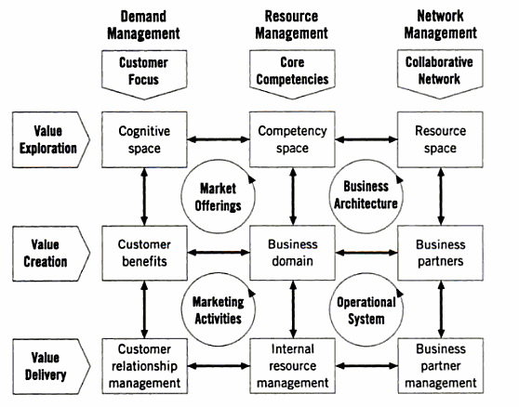

(SINGLE SPACE , after graph, Times New

**Figure nr. 1. A Holistic Marketing Framework (Graph title, Center, Times New Roman, bold, 12 pt.)**

Source: Philip Kotler, Dipak Jain, and Suvit Maesincee, *Marketing moves: a new approach to profits, growth, and renewal* (Boston: Harvard Business School Publishing Corporation, 2002), p. 29 (center, Times New Roman, 10 pt.)

(SINGLE SPACE, Times New Roman, 12 pt.)

**For tables**

(SINGLE SPACE, before table, Times New Roman, 12 pt.)

**Table no. 1. Drivers for Mastering the Value Stream in the New Business Landscape (Table title, Center, Times New Roman, bold, 12 pt.)**

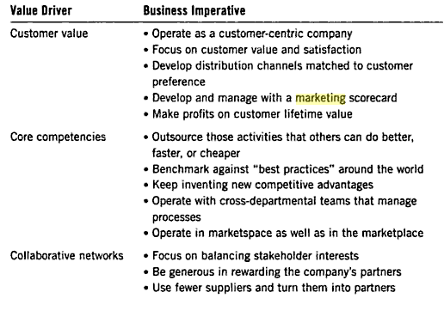

(SINGLE SPACE, after table, Times New Roman, 12 pt.)

Source: Philip Kotler, Dipak Jain, and Suvit Maesincee, *Marketing moves: a new approach to profits, growth, and renewal* (Boston: Harvard Business School Publishing Corporation, 2002), p. 19 (center, Times New Roman, 10 pt.)

(SINGLE SPACE, Times New Roman, 12 pt.)